**A PROJECT REPORT**

**ON**

**“SMART STUDENT ATTENDANCE SYSTEM USING QR CODE “**

SUBMITTED TO THE MSBTE, MUMBAI IN THE FULFILLMENT OF THE REQUIREMENTS

FOR THE AWARD OF THE DIPLOMA IN COMPUTER ENGINEERING/INFORMATION TECHNOLOGY

##### By

**Name of Students Enrollment No.**

1. Apurva A. Ingale 1701450031
2. Minakshi G. Sangolagi 1701450030
3. Mrunal K. Badade 1701450043
4. Shweta D. Pamane 1701450029
5. Sayali S. Tule 1701450080

**Under the guidance of Prof. MULE R. H**



**Academic Year * 2019 – 2020**

## DEPARTMENT OF COMPUTER ENGINEERING

Pune District Education Association

Institute of Technology

Hadapsar, Pune – 28.



## DEPARTMENT OF COMPUTER ENGINEERING

Institute of Technology

Pune - 411028.

**CERTIFICATE**

This is to certify that the project report entitles

**“SMART STUDENT ATTENDANCE SYSTEM USING QR CODE”**

Submitted by

**Name of Students Enrollment No.**

1. Apurva A. Ingale 1701450031
2. Minakshi G. Sangolagi 1701450030
3. Mrunal K. Badade 1701450043
4. Shweta D. Pamane 1701450029
5. Sayali S. Tule 1701450080

is a bonafide work carried out by them under the supervision of **Prof. MULE R. H** and it is submitted towards the full fulfillment of the requirement of Maharashtra Board of Technical Education, Mumbai for the award of the Diploma in of Computer Engineering / Information Technology.

**(Prof. MULE R. H.)** **(Prof. MULE R. H.) (Prof. SAWALE N. R.)**

Guide, Head Head Of Principal,

Department of Computer Department of Computer Institute of Technology, Hadapsar,

Engineering Engineering Pune-28

**Seal/Stamp of the College**

Place: - Institute of Technology, Pune

Date: - 23/09/2020



**EXAMINER CERTIFICATE**

The Project report entitled

**SMART STUDENT ATTENDANCE SYSTEM USING QR CODE**

**DIPLOMA IN COMPUTER ENGINEERING**

Submitted by

**Name of Students Enrollment No.**

1. Apurva A. Ingale 1701450031
2. Minakshi G. Sangolagi 1701450030
3. Mrunal K. Badade 1701450043
4. Shweta D. Pamane 1701450029
5. Sayali S. Tule 1701450080

Submitted towards the fulfillment of the requirement of Maharashtra Board of Technical Education, Mumbai for the award of the Diploma in of Computer Engineering / Information Technology is examined and certified.

*. . . . . . . . . . . . . . . . . . . . . . . . . . . . . . . . . . . . . . . . .*

Internal Examiner External Examiner

**(Prof. R. H. MULE) (Prof. R. H. MULE)**

Place: Institute of Technology, Pune.

Date: - 23/09/2020

DECLARATION

I undersigned hereby declare that I have completed and written Project report entitled “SMART STUDENT ATTENDANCE SYSTEM USING QR CODE”, during academic year 2019-2020 for the fulfillment of the requirement of Maharashtra Board of Technical Education, Mumbai for the award of the Diploma in of Computer Engineering.

This is my original work and it was not previously submitted for the award of any degree and diploma or similar title in any other examining body or board as per my knowledge.

Institute of Technology., Pune

CERTIFICATE BY GUIDE

This is to certify that Ms. **Apurva Ingale** From Institute Of Technology, Hadapsar, having Enrollment No.**1701450031,** has completed project of Final Year having title. **Smart Student Attendance System Using QR Code** during the Academic Year **2019-2020**. The project completed by individually in a group consisting of **5** persons under the guidance of the faculty guide.

Prof.

Internal Guide

Department of Computer Engineering

Institute of Technology., Pune

Place: Institute of Technology., Pune

Date: - 23/09/2020

CERTIFICATE BY GUIDE

This is to certify that Ms. **Minakshi Sangolagi** From Institute Of Technology, Hadapsar, having Enrollment No.**1701450030,** has completed project of Final Year having title. **Smart Student Attendance System Using QR Code** during the Academic Year **2019-2020**. The project completed by individually in a group consisting of **5** persons under the guidance of the faculty guide.

.

Prof.

Internal Guide

Department of Computer Engineering

Institute of Technology., Pune

Place: Institute of Technology., Pune

Date: - 23/09/2020

CERTIFICATE BY GUIDE

This is to certify that Ms. **Mrunal Badade** From Institute Of Technology, Hadapsar, having Enrollment No.**1701450043,** has completed project of Final Year having title. **Smart Student Attendance System Using QR Code** during the Academic Year **2019-2020**. The project completed by individually in a group consisting of **5** persons under the guidance of the faculty guide.

Prof.

Internal Guide

Department of Computer Engineering

Institute of Technology., Pune

Place: Institute of Technology., Pune

Date: - 23/09/2020

CERTIFICATE BY GUIDE

This is to certify that Ms. **Shweta Pamane** From Institute Of Technology, Hadapsar, having Enrollment No.**1701450030,** has completed project of Final Year having title. **Smart Student Attendance System Using QR Code** during the Academic Year **2019-2020**. The project completed by individually in a group consisting of **5** persons under the guidance of the faculty guide.

Prof.

Internal Guide

Department of Computer Engineering

Institute of Technology., Pune

Place: Institute of Technology., Pune

Date: - 23/09/2020

CERTIFICATE BY GUIDE

This is to certify that Ms. **Sayali Tule** From Institute Of Technology, Hadapsar, having Enrollment No.**1801450232,** has completed project of Final Year having title. **Smart Student Attendance System Using QR Code** during the Academic Year **2019-2020**. The project completed by individually in a group consisting of **5** persons under the guidance of the faculty guide.

Prof.

Internal Guide

Department of Computer Engineering

Institute of Technology., Pune

Place: Institute of Technology., Pune

Date: - 23/09/2020

**Appendix-B**

**PROGRESSIVE ASSESSMENT (PA) OF CAPSTONE PROJECT- EXECUTION**

**AND REPORT WRITING**

**Evaluation Sheet for Internal Assessment**

**Name of Student:** Apurva Ingale, Minakshi Sangolagi, Mrunal Badade, Shweta D Pamane, Sayali Tule

**Name of Programme:** Computer Engineering  **Semester:** Sixth

**Course Title:** Capstone Project: Execution and Report Writing  **Code:**22060.

**Title of the Capstone Project:** Smart Student Attendance Management System using QR code.

**A. POs addressed by the Capstone Project**

a) Analysis of the current attendance system and of the user needs.

b) Analysed Project definition and project requirement specification (PRS).

c) Analysis of current mobile devices and access to QR code.

d) Analysis of web application broadcasting to different mobile devices.

**B. COs addressed by the Capstone Project**

a) Better understanding of multi-tiers architectures

b) Analysing a current system and defining a new project from scratch.

c) Learning about bibliographic data formats

d) Understanding about utilities and data linking

**C. OTHER LEARNING OUTCOMES ACHIEVED THROUGH THIS PROJECT**

1. **Unit Outcomes (Cognitive Domain)**

a) Better understanding QR-based applications

b) Learning about mobile devices.

c) Learning about mobile applications and QR related applications.

d) Learning about Android coding.

1. **Practical Outcomes (in Psychomotor Domain)**
2. Learned QR code scanner working.
3. Learned about QR code data linking.
4. Learned QR code generation.
5. Application development skills improved.
6. **Affective Domain Outcomes**

a) Negotiation skills in an actively working environment

b) Report writing techniques.

c) Project presentation techniques.

d) Project management skills.

**Appendix-B**

# **Suggested Rubric for Capstone Project- Exceution and Report Writing**

|  |  |  |  |  |  |
| --- | --- | --- | --- | --- | --- |
| **Sr. no**. | **Characteristics to be Assessed** | **Poor** | **Average** | **Good** | **Excellent** |
| 1 | Problem/task identification  (Project Title) |  |  |  |  |
| 2 | Literature Survey/Industrial Survey |  |  |  |  |
| 3 | Project Proposal |  |  |  |  |
| 4 | Project Diary |  |  |  |  |
| 5 | Final Report Preparation |  |  |  |  |
| 6 | Presentation |  |  |  |  |
| 7 | Defence |  |  |  |  |

Contents

# Acknowledgment………………………………………………………I

# Abstsract……………………………………………………………….…….. II

SYNOPSIS 1

0.1 Relevant Objectives…………………………………………………1

0.2 Motivation…………………………………………………………………1

* 1. Hypothesis…………………………………………………………………...2

0.4 Problem Statement………………………………………………………….. 4

1. INTRODUCTION 6
   1. Project Idea………………………………………………………………..…6
   2. Motivational Survey………………………………………………………...7
   3. Methodology………………………………………………………………..
2. PROBLEM DEFINITION AND SCOPE 10
   1. Problem Definition 10
   2. Goal And Objective 10
   3. Technology And Associated Platform 10
      1. Hardware Specification 10

2.3.2 Software Specification 11

1. PROJECT PLAN 12
   1. Problem Definition 12
   2. Design And Implementation Constraints 12
   3. Software Requirement 12
   4. Feasibility Study 13
      1. Financial Feasibility 13
      2. Technical Feasibility 13
      3. Behavioral Feasibility 13
      4. Operational Feasibility 14
2. SOFTWARE REQUIREMENT AND SPECIFICATION 15
   1. Purpose And Scope Of Document 15
   2. External Interface Requirement 15
      1. User Interfaces 15
      2. Hardware Interfaces 15
      3. Software Interfaces 16
   3. Data Flow Diagram 17
      1. DFD Level 0 17
      2. DFD Level 1 17
      3. DFD Level 2 18
      4. DFD Level3 19
   4. UML Diagrams 19
      1. Use Case Diagram 19
      2. Activity Diagram 20
      3. Sequence Diagram 21
      4. Class Diagram 22

# DETAILED DESIGN DOCUMENT 23

* 1. Proposed System 26
  2. PREPROCESSING 26
     1. System Features -I (Functional Requirements)
     2. System Features-II (Non-Functional Requirements)

1. RESULT
2. CONCLUSION & ANALYSIS

# ANNEXURE 45

REFERENCES

# ACKNOWLEDGMENT

I have a great pleasure in presenting this Project report on “SMART STUDENT ATTENDANCE SYSTEM USING QR CODE” and to express my deep regards towards those who have offered their valuable time and guidance in our hour of need.

I would like to express our sincere and whole hearted thanks to my project guide Prof PATIL V.J, Head of the department Prof. R. H. Mule and my Project co-coordinator Prof MULE R.H for contributing valuable time, knowledge, experience and providing valuable guidance in making this project a success.

I am also glad to express my gratitude and thanks to our Principal Prof. Nitin SAWALE for their constant inspiration and encouragement.

Finally, before ending I would like to express once again my gratitude and thanks to all my friends who are involved directly and indirectly in making my project success.

Name of Student

Apurva A. Ingale

Minakshi G. Sangolagi

Mrunal K. Badade

Shweta D. Pamane

Sayali S. Tule

# ABSTRACT

Smartphones are becoming more preferred companions to users than desktops or notebooks. Knowing that smartphones are most popular with users at the age around 26, using smartphones to speed up the process of taking attendance by university instructors would save lecturing time and hence enhance the educational process.The students will need to scan the code in order to confirm their attendance.

In this era of technology smartphones play a significant role in our day to day life. Nowadays smartphones can solve most of the problem very quickly and easily. It has made life of every person simple and easier with different social app, commercial app, problem solving app, app for education and marketing etc.

Name of Student

Apurva A. Ingale

Minakshi G. Sangolagi

Mrunal K. Badade

Shweta D. Pamane

Sayali S. Tule

# SYNOPSIS

Project Title: “SMART STUDENT ATTENDANCE SYSTEM USING QR CODE”

Internal Guide: Prof.

Technical Keywords: *- QR, attendance, system, professor, student, Mobile Computing; Attendance System; Educational System; GPS*

* 1. Relevant Objectives

The Objective of the proposed application are as follows:

“QR Code Based Attendance Management System” is a combination of two android

“QR Code Based Attendance Management System” is a combination of two android

“QR Code Based Attendance Management System” is a combination of two android applications developed for taking and storing the attendance of the students on the daily basis in the college. Here the professor, who is handling the subjects, will be responsible to mark the attendance of the students. Each staff will be given an android application that is used for taking attendance and generate the overall attendance status. An accurate report based on the student attendance is generated here. Report of the student’s attendance on weekly and monthly basis is generated as desired. The main objective of the automated attendance system is to computerize the traditional way of recording attendance and provide an efficient and automated method to track attendance in institutions.

* 1. Motivation

Advantages of QR Code Based Smart Attendance System:

• Provide better security.

• Maintenance of the system is easy and cost effective.

• Generate the result quickly.

• Provide accurate and efficient data.

• User friendly.

* 1. Hypothesis
     1. Plan of Project Execution

Table 1.1 summarises various tasks being carried out in estimated duration of weeks. Figure 1.1 and Figure 1.2 shows Gantt chart of various activities against timescale in weekly manner.

Table 1.1: Timeline schedule of the Project

|  |  |  |
| --- | --- | --- |
| Work Task | Description | Duration |
| Basic Study | Related work done for Compendium | 2 weeks |
| Review of papers | Analysis of different techniques  used in text summarization | 2 weeks |
| Problem Formulation | Critical analysis and results  achieved in research | 2 weeks |
| Literature Survey | Comparison of technology Studied  and result analysis | 2 weeks |
| Objective of Topic | find some objectives related to sys-  tem | 2 weeks |
| Design of Mathematical Model | Set theory and mathematics re-  quired while designing the system | 4 weeks |
| Software requirement  and Specification | installation and understanding of  software required for execution of new system | 2 weeks |
| Detailed Design Documents | UML diagrams and System Struc-  Ture | 2 weeks |
| Implementation of base  Paper | GUI coding and first module | 3 weeks |
| Selection of data set | Data set Searching and Creation | 2 weeks |
| Implementation of proposed System | implementation of Module 2 and  module 3 | 3 weeks |
| Testing of system | Test system quality, fix errors if any  and improve if needed. Test system for different dataset | 2 weeks |
| Report writing | Prepare initial report | 2 weeks |
| Final report with modification | Prepare and modify initial report | 2 weeks |

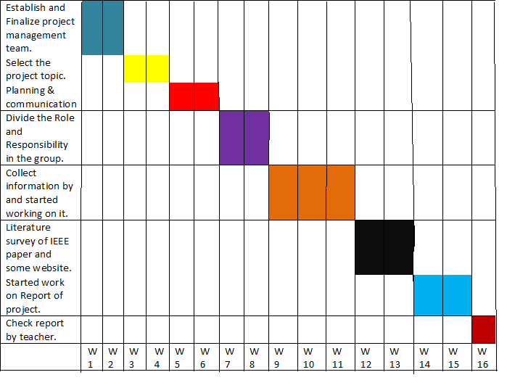

Figure 1.1: Gantt chart of Timeline Schedule 1

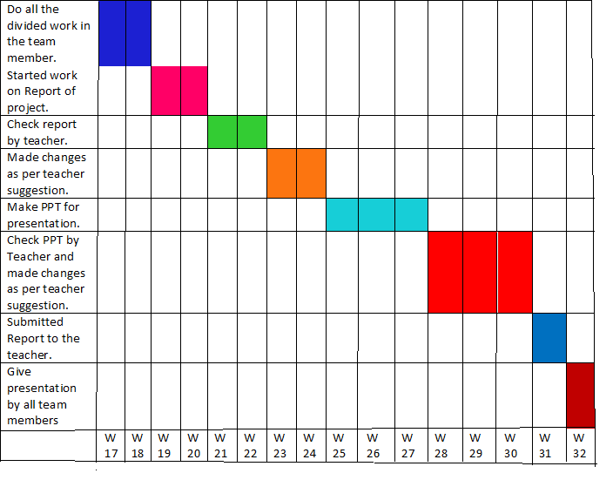

Figure 1.2: Gantt chart of Timeline Schedule 2

* 1. Problem Statement
* Development of a SMART QR CODE BASED ATTENDANCE SYSTEM.
* Integrating Android device with QR code and SQLite to store attendance results.
* Analyzing the attendance on weekly and monthly basis.

# INTRODUCTION

* 1. Project Idea:

In past day’s student mark their attendance on paper but sometimes there are chances of losing the paper. In that case we cannot calculate the attendance of students. So to overcome these issues we implement the system that will hide all student information (identity card) inside the QR Code .So that when student will scan that QR Code at that time ,date and time of scanning QR Code will be stored in database..

* 1. Methodology:

To achieve the above discussed objectives, a step-by-step methodology has been followed. The details of methodology are given below:

• Develop a QR code generator android app using the details of student such as roll number, student ID.

• Develop an Android app that take the attendance with respect to the specific subject and generate the student attendance sheet as per attendance details.

* + 1. Software requirement

• Android Studio

• Android OS 4.2+ (Mobile)

• MS Excel

* + 1. Hardware requirement

• Android Smartphone running Android OS version 4.0.3(API level 15)+

* + 1. Input/output

• Input: QR code, Bar code

• Output: XLS and CSV sheet

* + 1. Database used

•SQLite Database

* 1. Literature Survey:
     1. Paper Name: Bluetooth Based Attendance Management System Author

Name: Vishal Bhalla, TapodhanSingla, AnkitGahlot, Vijay Gupta

Bluetooth Smart is a wireless technology aimed at innovative applications in the healthcare, fitness, beacons, security, and home entertainment industries. The technology makes use of electronic tags to facilitate automatic wireless identification, with a Bluetooth Smart enabled device. We are attempting to solve the problem of attendance monitoring using a Bluetooth Smart based system in this paper. This application of Bluetooth Smart to student attendance improves the time taken during manual attendance and human errors and provides administrators the statistics of attendance scores for use in further managerial decisions.

* + 1. Paper Name: Online Attendance Management System Using RFID with Object Counter Author

Name:AnkitaAgrawal and AshishBansal

Educational institutions proprietors in our country and the complete world are concerned about regularity of student attendance. Student taken as a whole academic performance is affected by it. The predictable method of taking attendance by calling names or signing on paper is extremely time consuming, and hence inefficient. Radio Frequency Identification (RFID) based attendance system is one of the answers to address this problem. A system that can automatically capture student’s attendance by flashing their student card at the RFID reader and save all the mentioned difficulties.A system that has been built using the web-based applications such as JSP, MySQL and Apache to cater the recording and reporting of the students‟ attendances.NetBeans IDE 6.1 is used for developing the overall system. We have proposed the system in this paper using C#. Microsoft Visual Studio is used for the system designing. Also, the issue related to fake /false attendance from beginning to end the RFID system has been addressed, we eliminate it by using a special object counter for the leader count.

* + 1. Paper Name :Fingerprint Based Student Attendance System Using GSM Author name: Pallavi Verma1, Namit Gupta

In this paper provides the design method of portable fingerprint based student attendance system using GSM. The system includes terminal fingerprint acquisition module and attendance module. It can realize automatically such functions as information acquisition of fingerprint, processing, and wireless transmission, fingerprint matching and making an attendance report. After taking the attendance, this system sends the attendance of every student to their parent’s mobile through GSM. Attendance system facilitates access to the attendance of a particular student in a particular class. This system eliminates the need for stationary materials and personnel for the keeping of records.

# PROBLEM DEFINITION AND SCOPE

* 1. Problem Definition
* Development of a SMART QR CODE BASED ATTENDANCE SYSTEM.
* Integrating Android device with QR code and SQLite to store attendance results.
* Analyzing the attendance on weekly and monthly basis.
  1. Goal And Objective

“QR Code Based Attendance Management System” is a combination of two android

“QR Code Based Attendance Management System” is a combination of two android applications developed for taking and storing the attendance of the students on the daily basis in the college. Here the professor, who is handling the subjects, will be responsible to mark the attendance of the students. Each staff will be given an android application that is used for taking attendance and generate the overall attendance status. An accurate report based on the student attendance is generated here. Report of the student’s attendance on weekly and monthly basis is generated as desired. The main objective of the automated attendance system is to computerize the traditional way of recording attendance and provide an efficient and automated method to track attendance in institutions.

* 1. Technology And Associated Platform
     1. Hardware Specification:
* Hard Disk: 4.00 GB
* RAM: 4.00 GB
* Processor: Processor: Intel® Core™ i3-7020U CPU @ 2.30GHz
  + - Software Specification
* Application Libraries:
* Language: JAVA
* Tools: 4 GB RAM Laptop , 2 mobile phones
* Operating System: Windows 10 OS, 64-bit OS, x64-based Processor

# PROJECT PLAN

* 1. Problem Definition

Development of a SMART QR CODE BASED ATTENDANCE SYSTEM.

• Integrating Android device with QR code and SQLite to store attendance results.

• Analyzing the attendance on weekly and monthly basis.

Development of a SMART QR CODE BASED ATTENDANCE SYSTEM.

• Integrating Android device with QR code and SQLite to store attendance results.

• Analyzing the attendance on weekly and monthly basis.

• Development of a SMART QR CODE BASED ATTENDANCE SYSTEM.

• Integrating Android device with QR code and SQLite to store attendance results.

• Analyzing the attendance on weekly and monthly basis.

• Development of a SMART QR CODE BASED ATTENDANCE SYSTEM.

• Integrating Android device with QR code and SQLite to store attendance results.

• Analyzing the attendance on weekly and monthly basis.

* Development of a SMART QR CODE BASED ATTENDANCE SYSTEM.
* Integrating Android device with QR code and SQLite to store attendance results.
* Analyzing the attendance on weekly and monthly basis.
  1. Design And Implementation Constraints

The following are the constraints that will affect the manner in which the software will function☹

* User must select valid filename from dataset.
* User must have knowledge about dataset.
* User must have the basic knowledge of the application.
* User must have knowledge of text mining.
* Easy Graphical user Interface for ease of usage.
* Time to generate summary must be as minimum as possible.
* The accuracy of the system should be good as compared to other text summarization method.)
  1. Software Requirement
* Technology Used: Android pie version, Eclipse, tomcat server
* Tools:4 GB RAM Laptop , 2 mobile phones
* Operating System: Windows 10 OS, 64-bit OS, x64-based Processor
  1. Feasibility Study

The feasibility study comprise of an initial investigation into personnel will be required. Feasibility study will help to make informed and transparent decisions at crucial points during the developmental process.

Feasibility has following dimensions and here is a brief description in context to present system.

* Economic feasibility: The developed system is time effective because attendance is marked automatically. It is also cost effective because of no use of paperwork.
* Technical feasibility: The system is economic and it does not use any other additional Hardware and software.
* Behavioral feasibility: The system is user friendly.

# SOFTWARE REQUIREMENT AND SPECIFICATION

* 1. Purpose And Scope Of Document

(In this Project we discuss about the proposed system in detail. We discussed about the hardware and software required for the proposed system, functional and nonfunctional requirement, etc.)

* + 1. Project Scope
       1. (This system can be developed to implement for generating abstractive summary from the research paper
       2. We used feature specific sentence extraction method which improve the performance of the summerization technique.)
  1. External Interface Requirement
     1. User Interfaces

(The proposed system gives the user friendly GUI, the system provides the followinng GUI:

* User selects the research paper window.
* Extractive summary window
* Abstractive summary window)
  + 1. Hardware Interfaces
* RAM: 4.00 GB
* Processor: Intel® Core™ i3-7020U CPU @ 2.30GHz
  + 1. Software Interfaces
* Technology Used: Android pie version, Eclipse, tomcat server
* Tools:4 GB RAM Laptop , 2 mobile phones
* Operating System: Windows 10 OS, 64-bit OS, x64-based Processor
  1. Data Flow Diagram

A DFD shows what kind of information will be input to and output from the system, where the data will come from and go to, and where the data will be stored. It does not show information about the timing of processes, or information about whether processes will operate in sequence or in parallel.

|  |  |
| --- | --- |
| **Symbol** | **Description** |
| [dfd symbol](https://meeraacademy.com/wp-content/uploads/2016/09/arro.jpg) | **Data Flow** – Data flow are pipelines through the packets of information flow. |
| [dfd process](https://meeraacademy.com/wp-content/uploads/2016/09/process.jpg) | **Process:**A Process or task performed by the system. |
| [dfd entry symbol](https://meeraacademy.com/wp-content/uploads/2016/09/Entity.jpg) | **Entity:**Entity is object of the system. A source or destination data of a system. |
| [dfd source symbol](https://meeraacademy.com/wp-content/uploads/2016/09/source.jpg) | **Data Store:** A place where data to be stored. |

* + 1. DFD Level 0

The context level data flow diagram (d f d) is describe the whole system. It shows the all user module who operate the system. The student attendance management system data flow diagram shows there are three users to run the system Admin, Staff, Student, Parent.

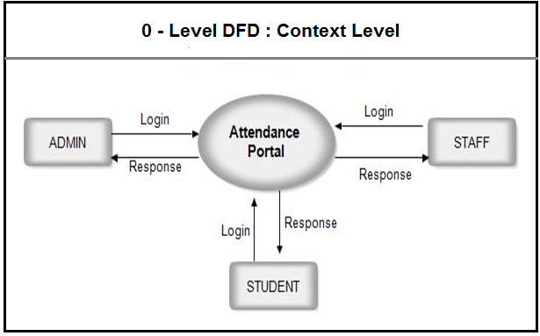

Example

Figure 6.1: DFD Level 0

* + 1. DFD Level 1

### ADMIN – DATA FLOW DIAGRAM:

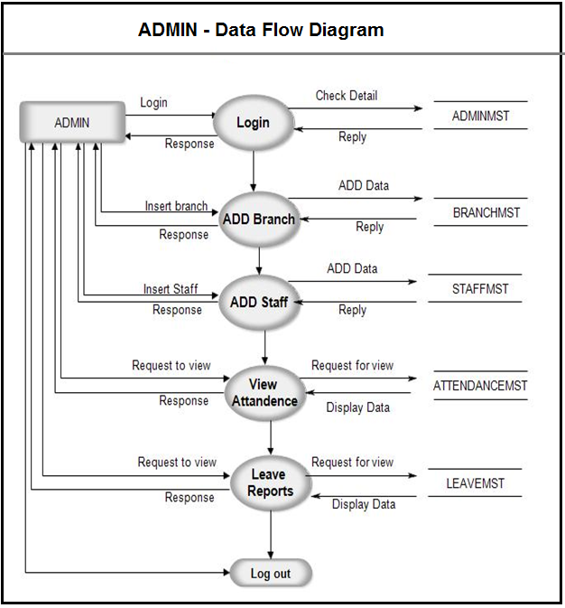

**FIGURE 2: ADMIN-DATA FLOW DIAGRAM**

Example

Figure 2: DFD Level 1

* + 1. DFD Level 2

### STAFF SIDE DATA FLOW DIAGRAM:

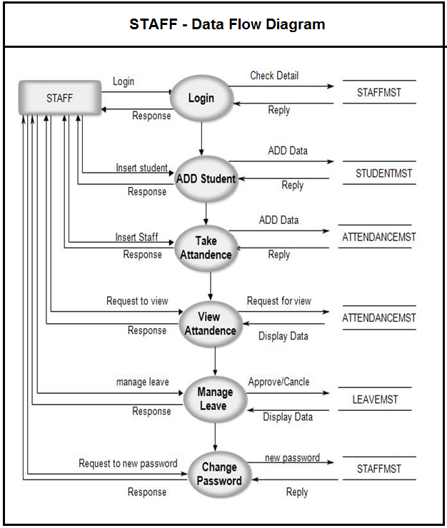

**FIGURE 3: STAFF** - **DATAFLOW DIAGRAM**

Example

Figure 6.3: DFD Level 2

* + 1. DFD Level 3

STUDENT SIDE DATA FLOW DIAGRAM:

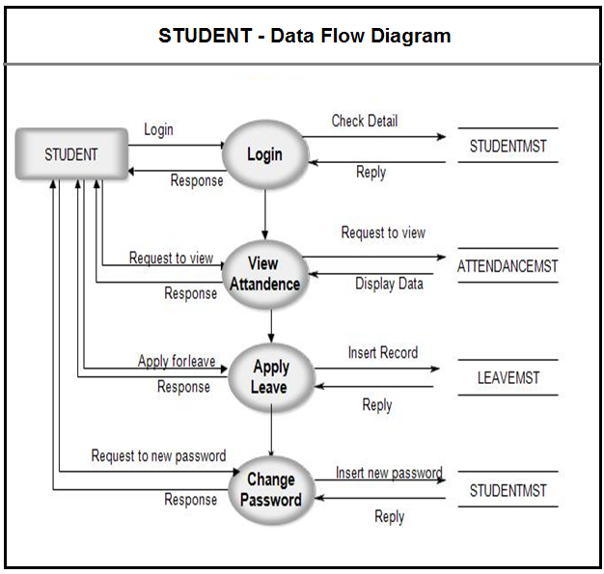

**FIGURE4: STUDENT-DATAFLOW DIAGRAM**

* 1. UML Diagrams
     1. Use Case Diagram

The use case diagram are usually referred to as behavior diagram used to describe the actions of all user in a system. All user describe in use case are actors and the functionality as action of system.  
The Use case diagram is a collection of diagram and text together that make action on goal of a process.

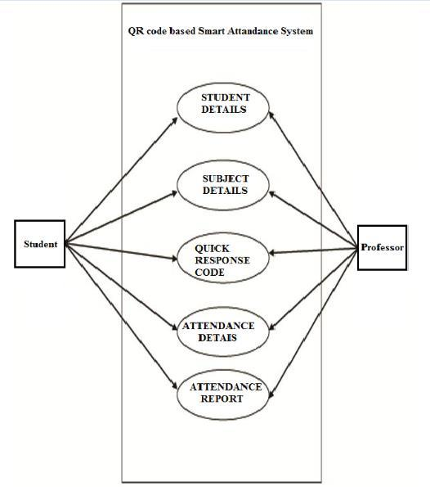

**FIGURE 7: USE-CASE--DIAGRAM**

* + 1. Activity Diagram

The activity diagram used to describe flow of activity through a series of actions. Activity diagram is a important diagram to describe the system. An activity diagram shows the overall flow of control.

**ACTIVITY DIAGRAM SYMBOLS**

|  |  |
| --- | --- |
| **Symbol** | **Description** |
| activity diagram | **Solid Circle :**Start the process of activity diagram |
| activity diagram | **Rounded Rectangle:**Event and Activity. |
| activity diagram | **Solid Line:** Sequence from one activity to next. |
| activity diagram | **Dotted Store:** Flow of information between events. |
| activity diagram | **Document:** Represent report or document. |
| activity diagram | **Diamond:** Branch. |
| activity diagram | **Table:** A place where data to be stored. |
| activity diagram | **End of Process.** |

* + 1. Sequence Diagram

A sequence diagram shows object interactions arranged in time sequence. It depicts the objects and classes involved in the scenario and the sequence of messages exchanged between the objects needed to carry out the functionality of the scenario. Sequence diagrams are typically associated with use case realizations in the [Logical View](https://en.wikipedia.org/wiki/4%2B1_architectural_view_model) of the system under development. Sequence diagrams are sometimes called event diagrams or event scenarios.

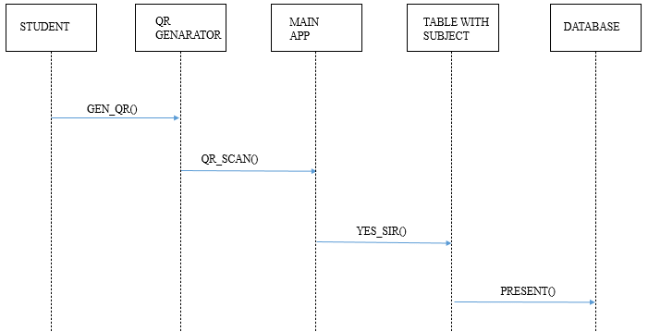

Example

Figure 6.6: Sequence Diagram

* + 1. Class Diagram

## Attendance Management System Class Diagram describes the structure of a Attendance Management System classes, their attributes, operations (or methods), and the relationships among objects

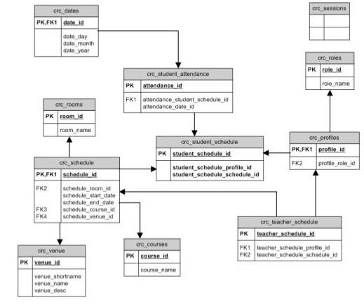

1. DETAILED DESIGN DOCUMENT
   1. Proposed System

• User Friendly

• Reports are easily generated

• Very less paper work

• One spot solution for attendance calculation

• User Friendly

• Reports are easily generated

• Very less paper work

• One spot solution for attendance calculation

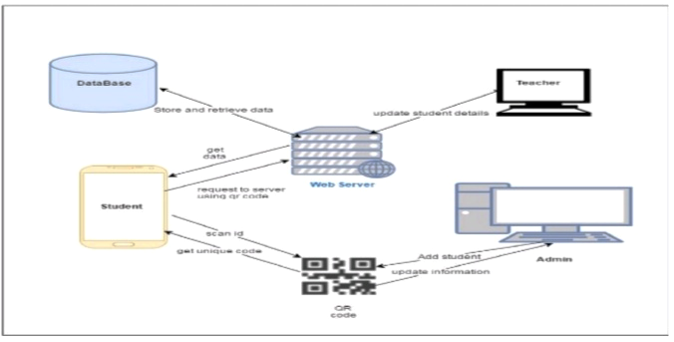

Example Figure : System architecture

* 1. The Proposed System

# The system lies between online learning and traditional learning as a facilitation for the attendance record-keeping process, in a way that enriches the lecture time so that it can better be utilized in giving useful materials rather than wasting the time taking attendance. The system requires a simple login process by the class instructor through its Server Module to generate an encrypted QR code with specific information. This can be done at any time before the class. During the class, or at its beginning, the instructor displays an encrypted QR code to the students. The students can then scan the displayed QR code using the system Mobile Module, provided to them through the smartphone market by the university.

# Along with the student’s facial image captured by the mobile application at the time of the scan, the Mobile Module will then communicate the information collected to the Server Module to confirm attendance. The whole process should take less than a minute for any student as well as for the whole class to complete their attendance confirmation. Smartphones may communicate with the server via either the local Wi-Fi coverage offered by the institution or through the internet.

* 1. PREPROCESSING
     1. System Features-I (Functional Requirements)

(Proposed system accuracy graph generation will be done, on just hit of a button.)

* Execution time and memory used graph will be done.
* It provides an easy interface to user.
* It generates the grammatically correct summary.
* It generate extractive and abstractive summary.
  + 1. System Features-II (Non-Functional Requirements)
* The time required for processing the application will be less.
* The application must be scalable and reliable.
* Time saving i.e. time to generate extractive and abstractive summary wii be very less.
* Accurate i.e. the accuracy of the generating abstract should be good as compared to other text summarization method.
* Portable i.e This software is portable to any system with the requirements specified
  + 1. ADVANTAGES
* Less time consuming.
* Minimal hardware requirement
* Enhancing the mobility aspect of the existing attendance systems.
* Smart and Paperless work.
  + 1. APPLICATION
       - School
       - College
       - University
       - Small Scale Organization
       - Large Scale Organization

1. RESULT (OUTPUT)

Teacher’s login:-

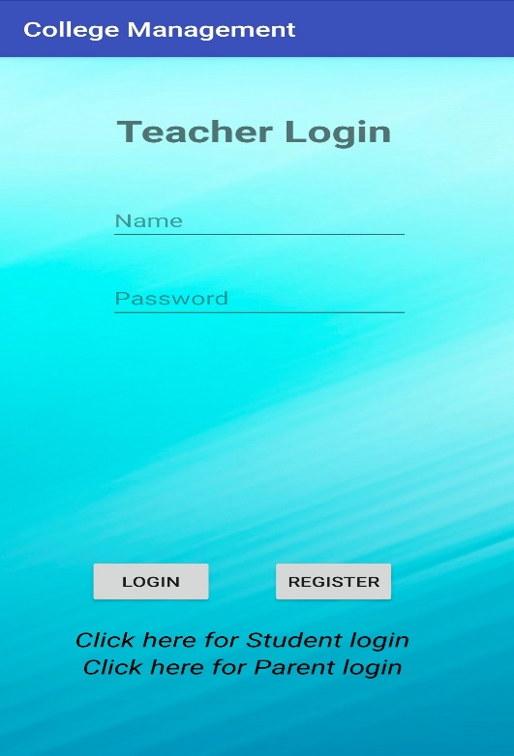 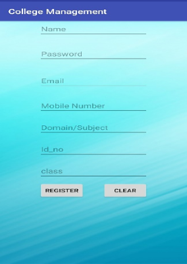

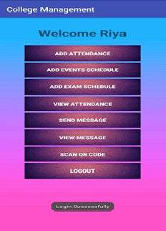 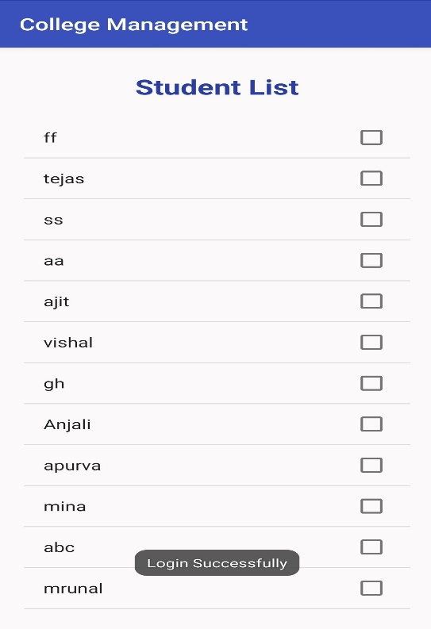

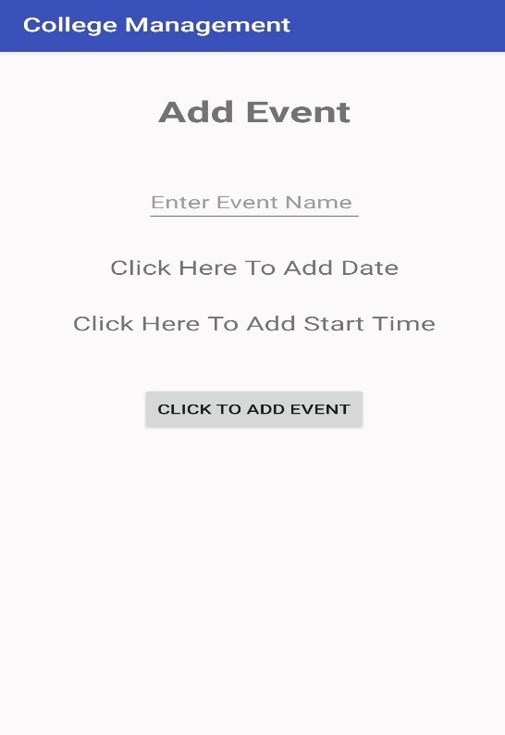 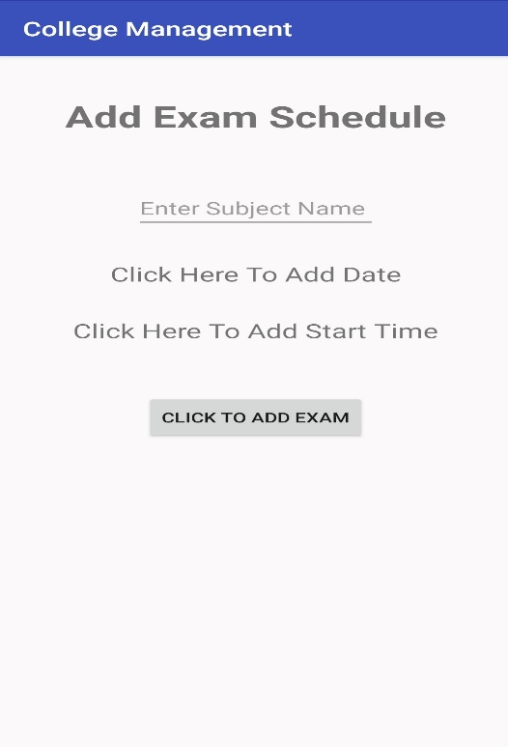

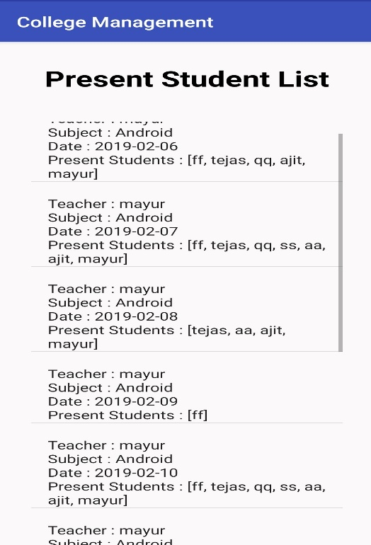 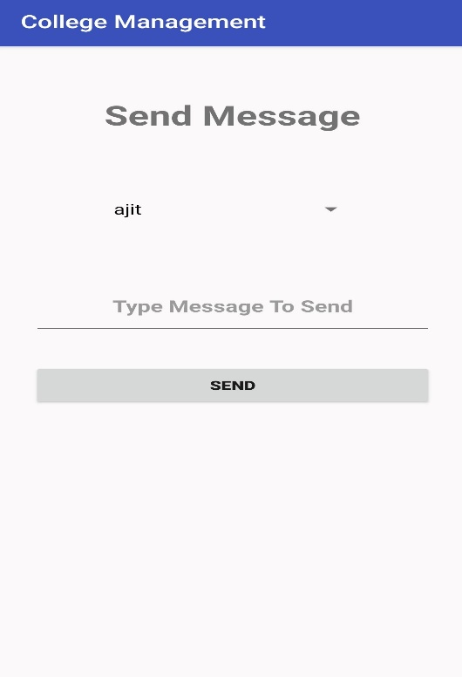

 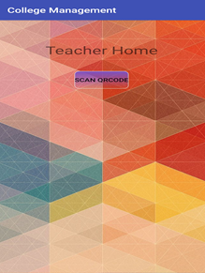

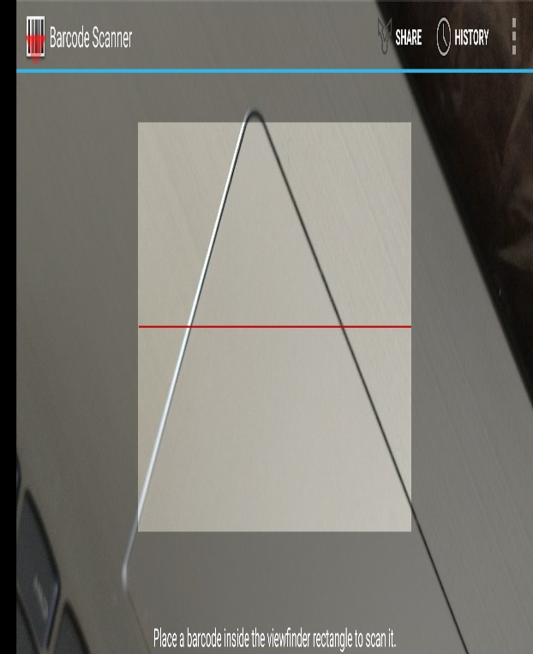

Students Login:-

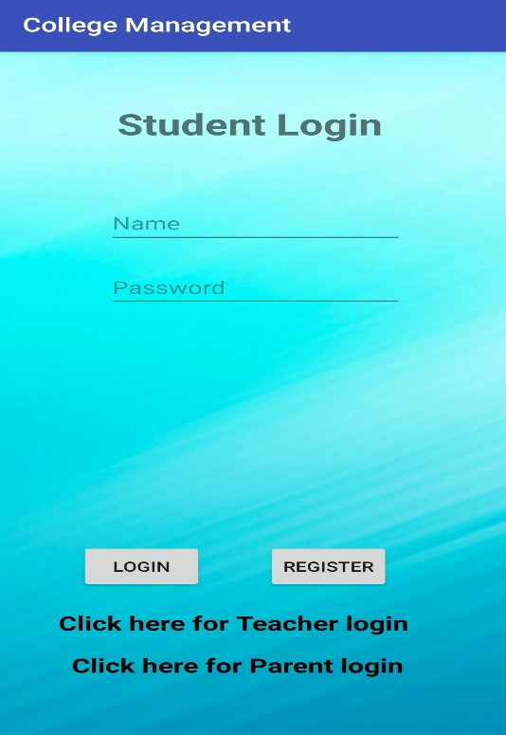 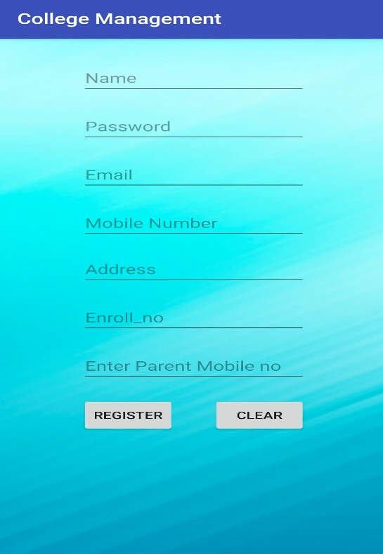

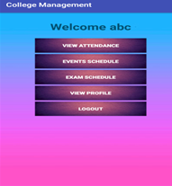

Parents Login:-

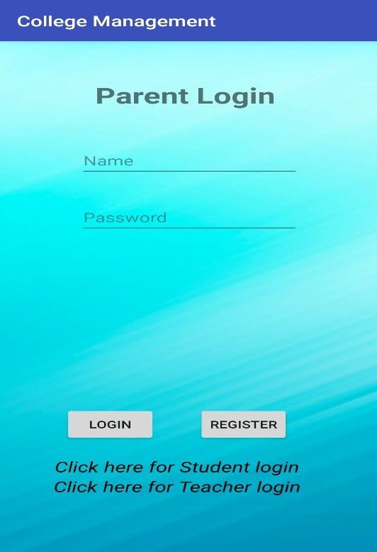 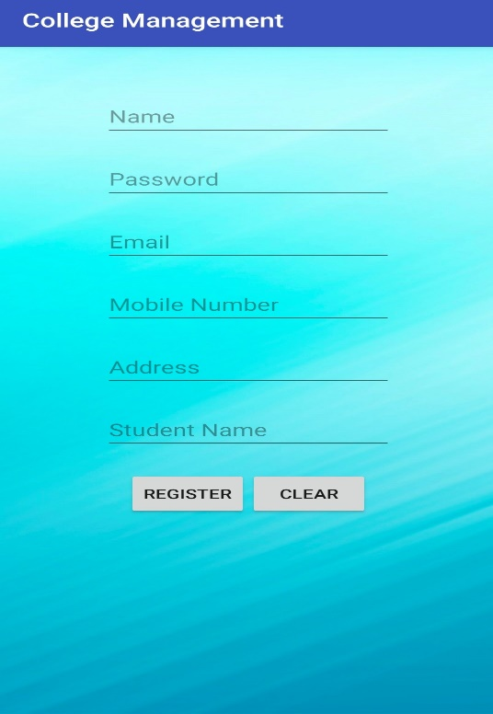

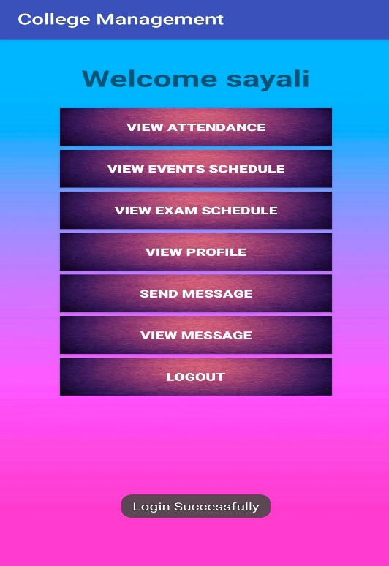 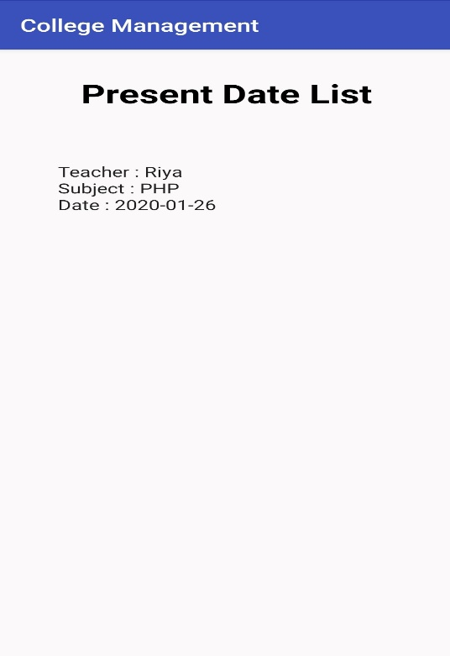

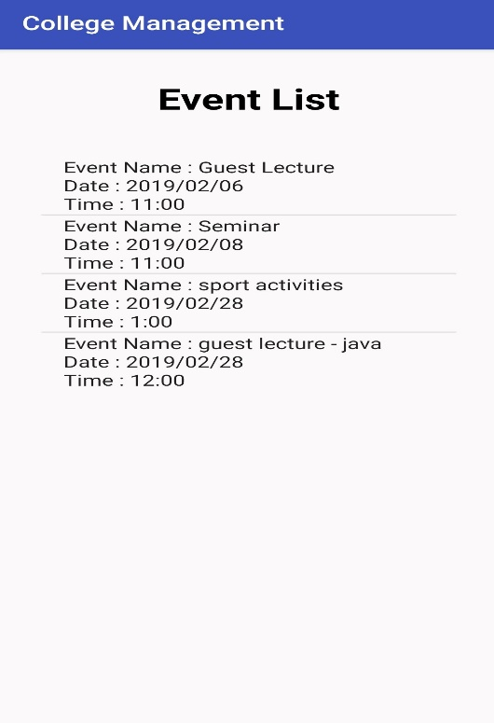 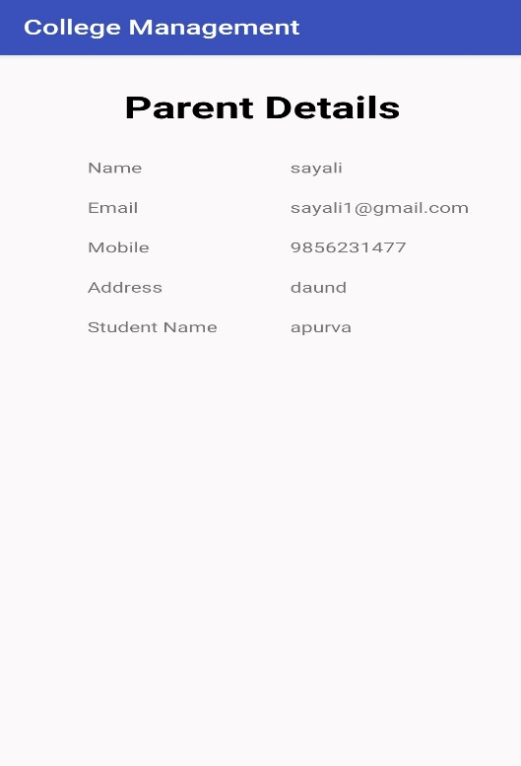



Web Part:-

This is only for admin(Head Of Department, Principle Of College or University).

**Step 1:-**

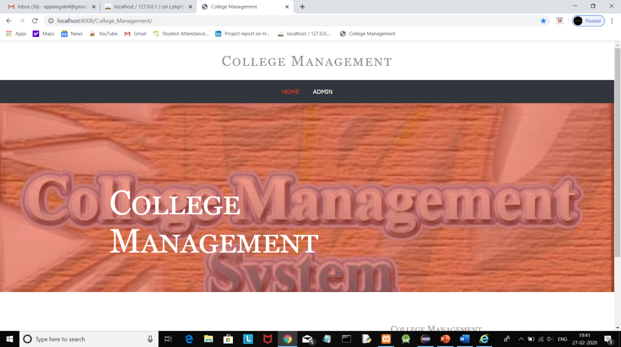

**Step 2:-**

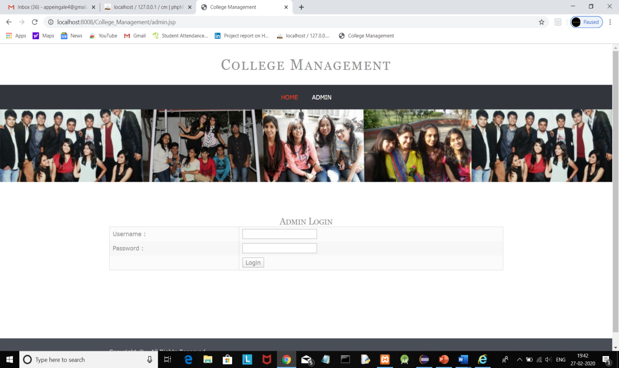

**Step 3:-**

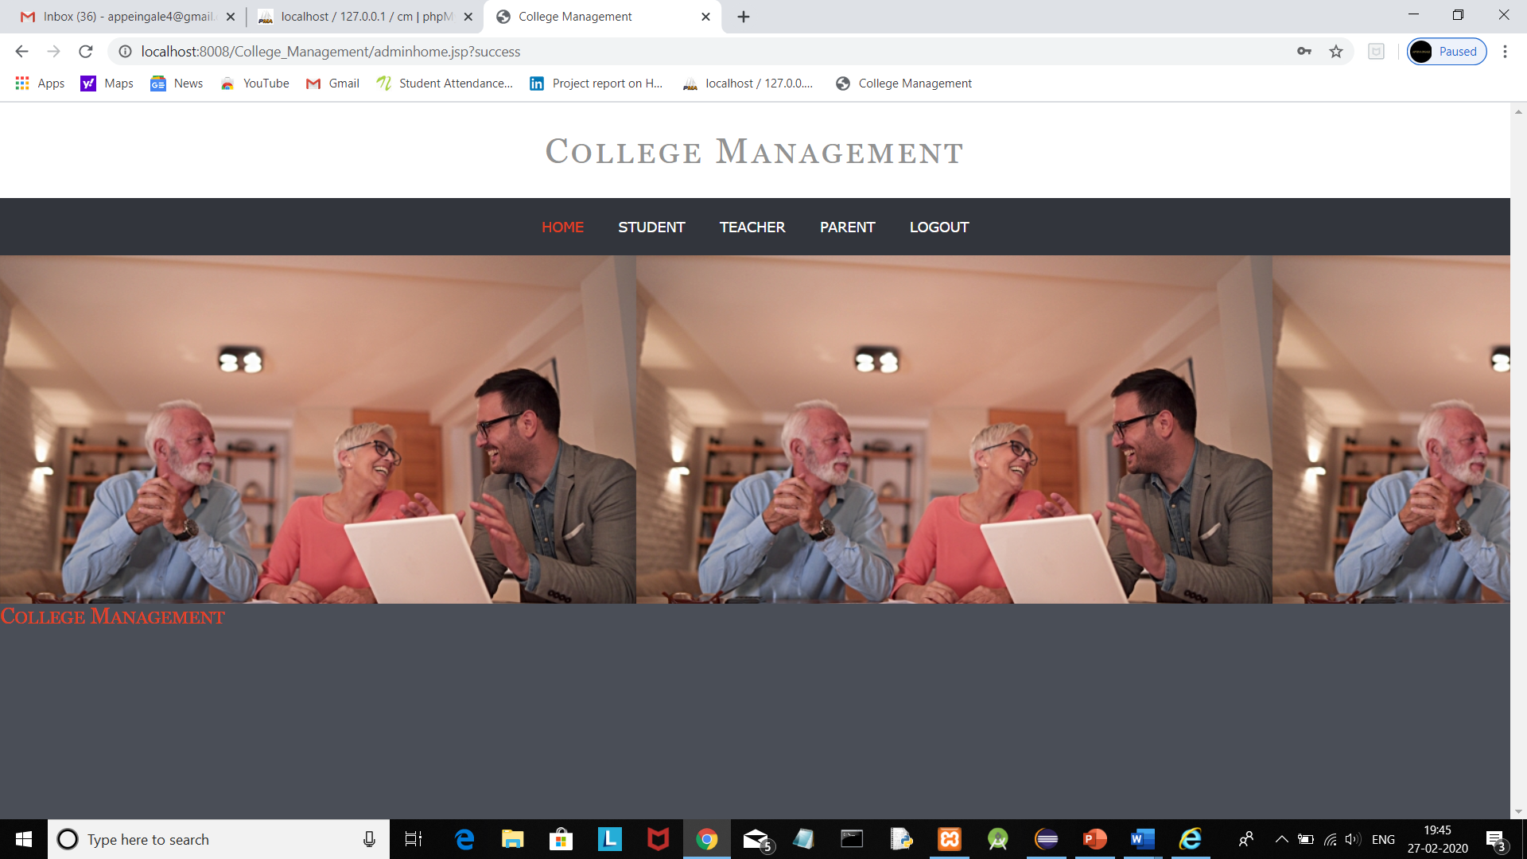

**Step 4:-**

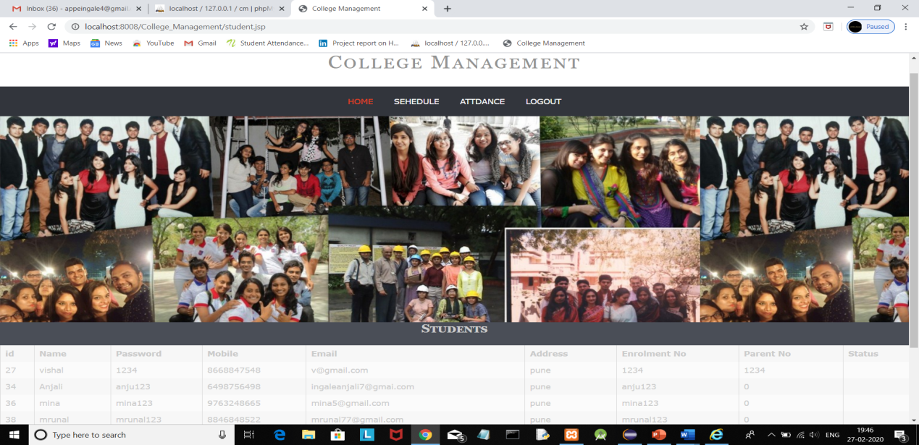

**Step 5:-**

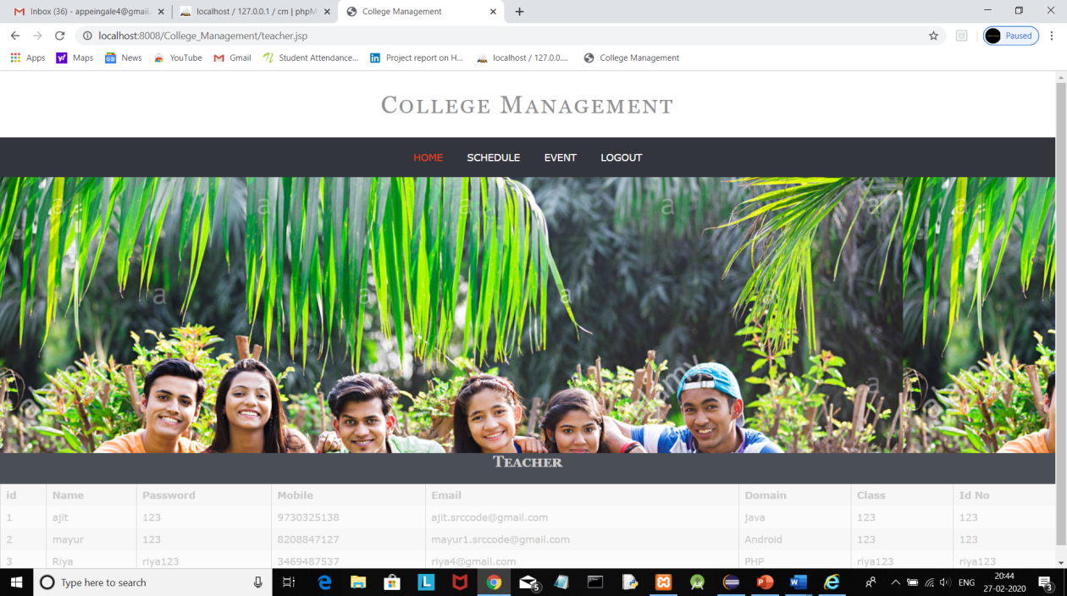

**Step 6:-**

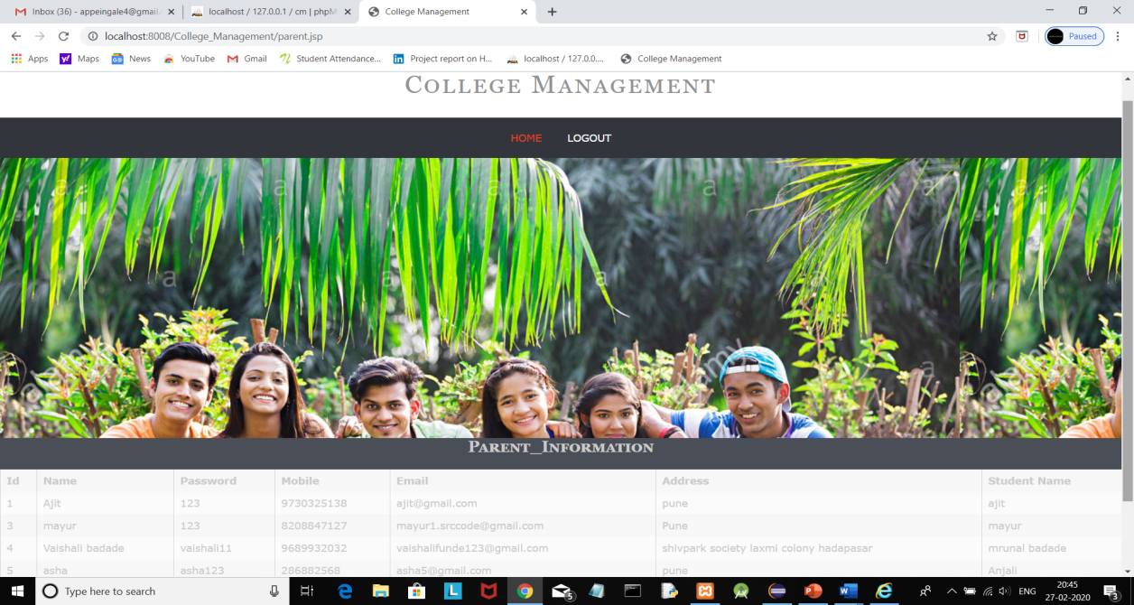

**Step 7:-**

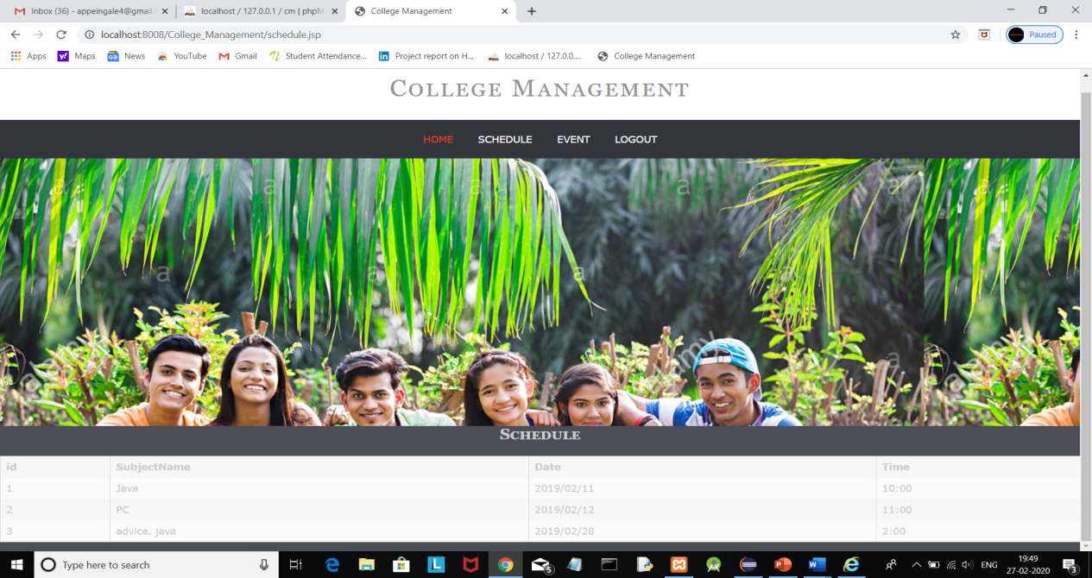

**Step 8:-**

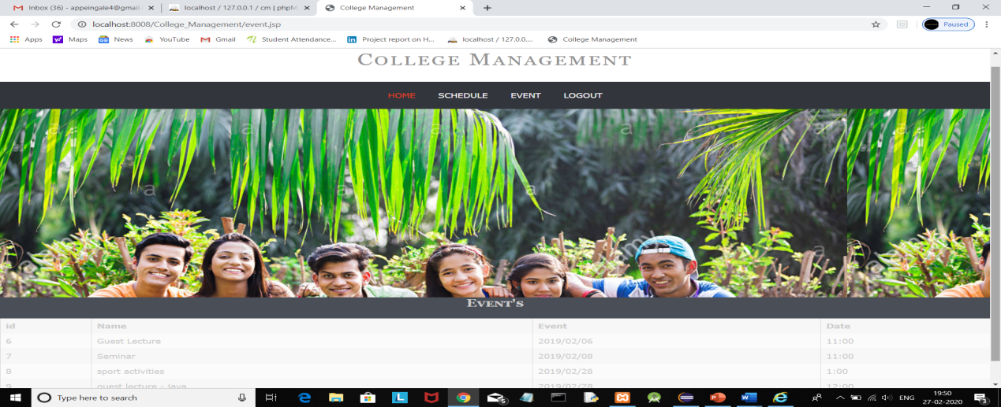

1. CONCLUSION AND ANALYSIS

CONCLUSION:

The developed system presented in this paper has been successfully designed and tested. The student’s attendance status will be analysed and exported. Attendance monitoring system is very important in our daily life. It is possesses a really great advantage, among the whole types of code scanning technology, QR Code Based Smart Attendance System is the most accurate. In this project report, we have given an introduction of Attendance monitoring system and its advantage. It is an efficient method to store the attendance in the smart phone rather than wasting the paper.

ANALYSIS:

Standard security procedures require a simple username and password. Such information is called “Something you know” or “What you know”.Thus, it is easy

or “What you know”. Thus, it is easy for unauthorized users to

gain access to a user’s private data such as personal and

or “What you know”. Thus, it is easy for unauthorized users to

gain access to a user’s private data such as personal and

or “What you know”. Thus, it is easy for unauthorized users to

gain access to a user’s private data such as personal and

for unauthorized users to gain access to a user’s private data such as personal and financial details and then use that information to commit fraudulent acts.

Using a username and password together with a piece of

hardware or device that only the user has makes it harder for

potential intruders to gain access and steal that person’s

personal data or identity.

or “What you know”. Thus, it is easy for unauthorized users to

gain access to a user’s private data such as personal an“What you know”. Thus, it is easy for unauthorized users to gain access to a user’s private data such as personal and

or “What you know”. Thus, it is easy for unauthorized users to

gain access to a user’s private data such as personal and

The student’s attendance status will be analysed and exported. Attendance monitoring syste

REFERENCE

1. Smartphone Users Around the World – Statistics and Facts, http://www.go-gulf.com/blog/smartphone/ visited on February 12, 2014
2. Jamil, T. ; Dept. of Electr. & Comput. Eng., Sultan Qaboos Univ., Al Khod, Oman, Automatic attendance recording system using mobile telephone , Telecommunications Forum (TELFOR), 2011 19th 1297 - 1299
3. Shehu, V. ; Contemporary Sci. & Technol., South East Eur. Univ., Tetovo, Macedonia ; Dika, A. , Using real time computer vision algorithms in automatic attendance management systems, Information Technology Interfaces (ITI), 2010 32nd International Conference on 397 – 402
4. Saraswat, Chitresh; Kumar, Amit, An Efficient Automatic Attendance System using Fingerprint Verification Technique. International Journal on Computer Science & Engineering . 2010, Vol. 2 Issue 2, p264-269
5. Qinghan Xiao ; Interdept. Biometrics Working Group, Gov. of Canada, ON ; Xue Dong Yang, A facial presence monitoring system for information security, Computational Intelligence in Biometrics: Theory, Algorithms, and Applications, 2009. CIB 2009. IEEE Workshop on, March 30 2009-April 2 2009 , 69 – 76
6. Indoor Positioning: http://en.wikipedia.org/wiki/Indoor_positioning_system#cite_note-15 visited on January 10, 2014
7. “Android tutorials” [Online]. Available: https://developer.android.com/training/index.html
8. “Android tutorials” [Online]. Available: <https://www.tutorialspoint.com/android/>
9. “QR code integration with Android” [Online]. Available: https://github.com/zxing/zxing
10. “About Bar Code” [Online]. Available:http://files.microscan.com/whitepapers/barcode_basics.pdf
11. "ISS QR Code AIM Store: Historical Archive" [Online]. Available: Aimglobal.org
12. “Android Tutorial” [Online]. Available: <http://androidhive.com>
13. ISO/IEC 18004:2000, Information technology - Automatic identification and data capture techniques - Bar code symbology - QR Code, ISO, 2000.
14. S. Lisa and G. Piersantelli, “Use of 2d barcode to access multimedia content and the web from a mobile handset,” in GLOBECOM, 2008.
15. J. Gao, V. Kulkarni and R. Himanshu, “A 2d barcode-based mobile payment,” in MUE, 2009.
16. J. Gao, L. Prakash and R. Jagetesan, “Undersanding 2dbarcode technology and application in m-commerce - design and implementation of a 2d barcode processing solution,” in COMPSAC 2007, 2007.
17. A. R. Wane, S. P. Jamankar and O. V. Chandure, “An Effective mechanism for Ensuring Security of QR Code,” International Journal of Advanced Research in Computer Science, vol. 4, no. 6, pp. 175-179, 2013.
18. “TEC-IT Barcode Software - Barcode Overview - Reference,” 15 January 2018. [Online]. Available: http://www.tecit.com/download/PDF/Barcode_Reference_EN.pdf. [Accessed 2018 February 1].
19. G. J. Z. , V. H., S. S. and X. J., “A 2d-barcode based mobile advertising solution,” SEKE, pp. 466 - 472, 2009.
20. J. Sharman, “Japanese city keeps track of dementia patients with QR code nail stickers,” The Independent, 2016 December 2016. [Online]. Available: http://www.independent.co.uk/news/world/asia/japantrack-dementia-patients-qr-code-nail-stickersa7464256.html. [Accessed 12 March 2018].